**Please follow the steps to publish your project into github.io**

Go to the link [www.github.com](http://www.github.com/)

Click on the sign up button

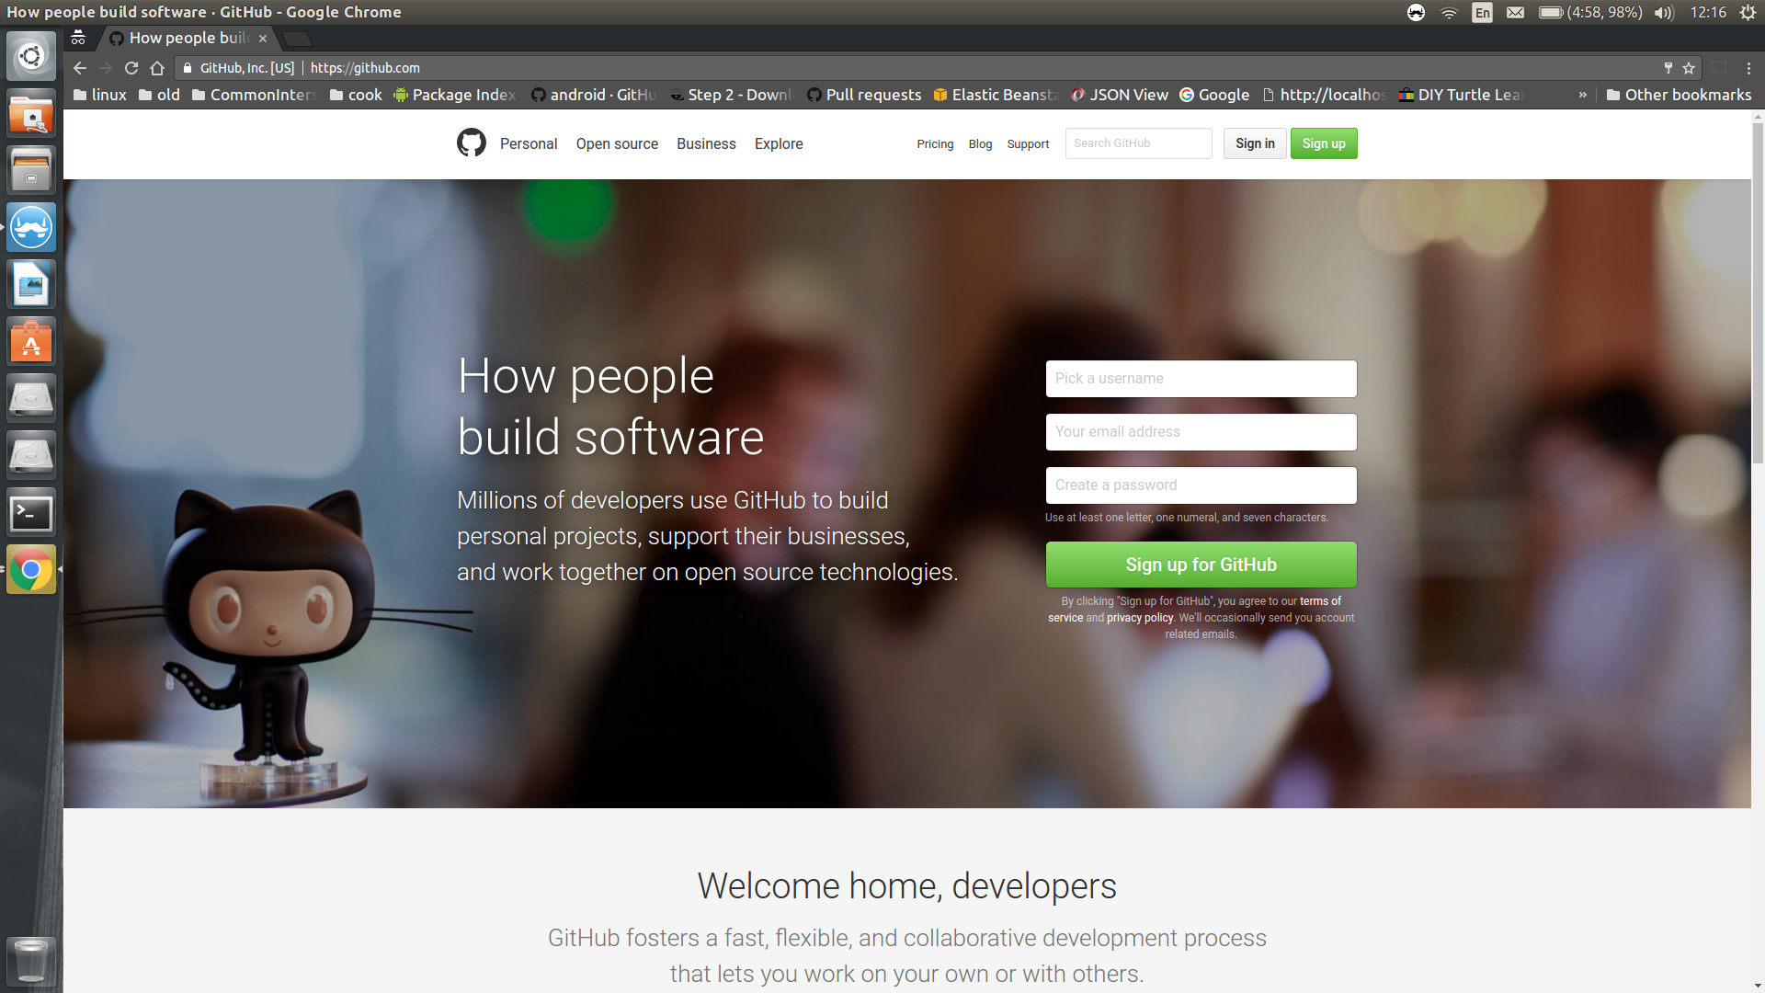

Fill in username, email-id and password. Make sure you can login to the email id, to verify your github account later.

Click on the "Create an account"

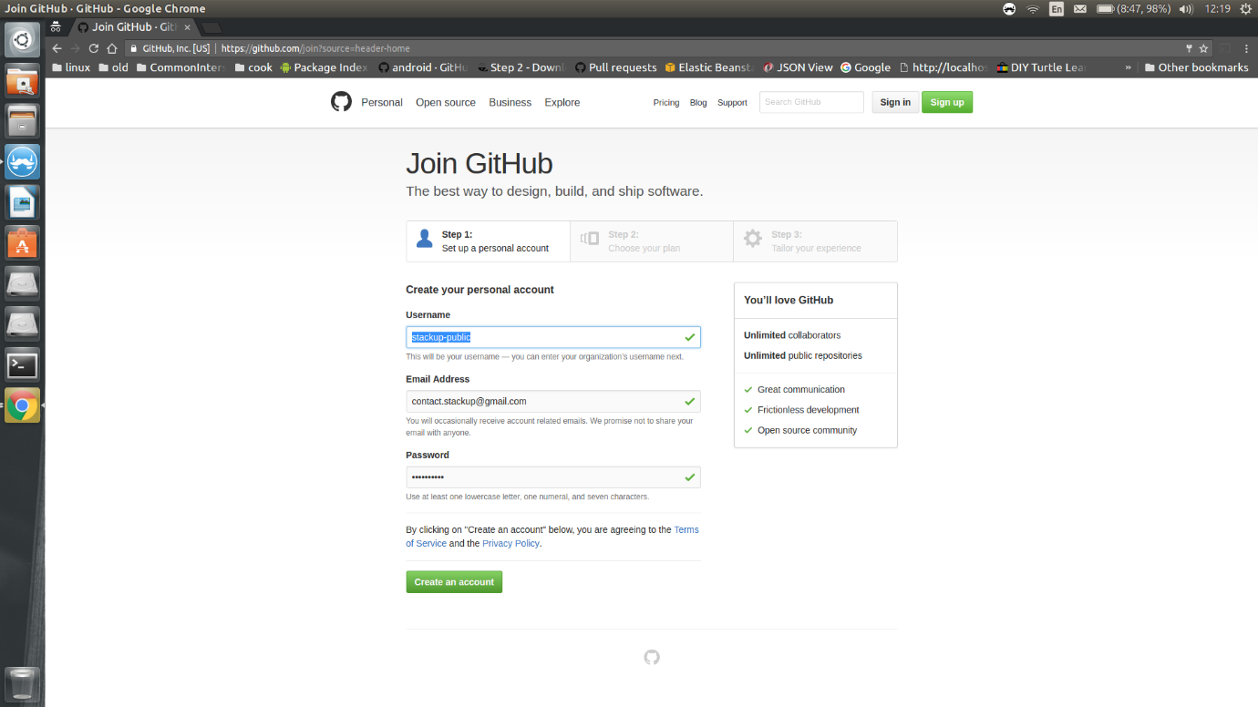

No need to change anything. Leave it as it is. and click "Continue"

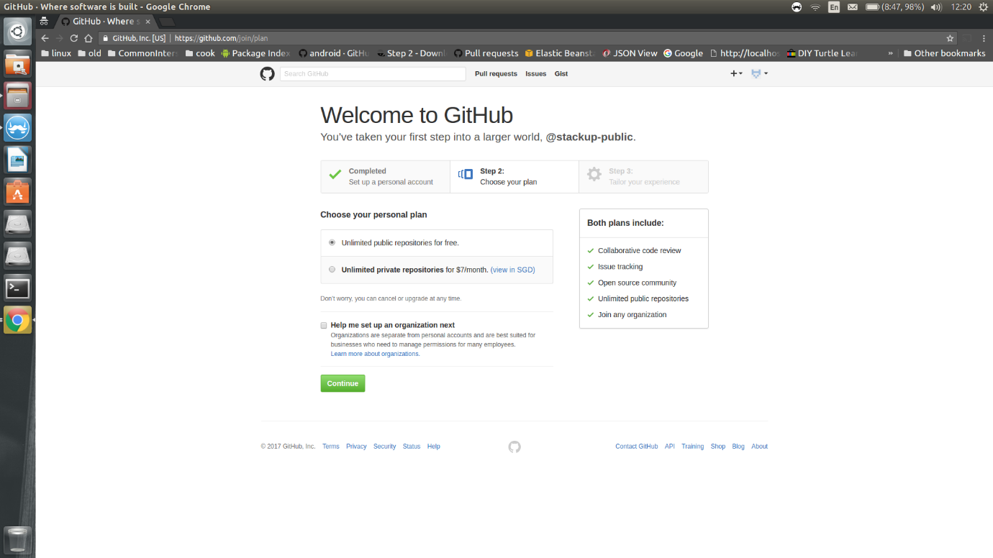

Click on "skip the step". If you wish, you can submit. But it’s optional.

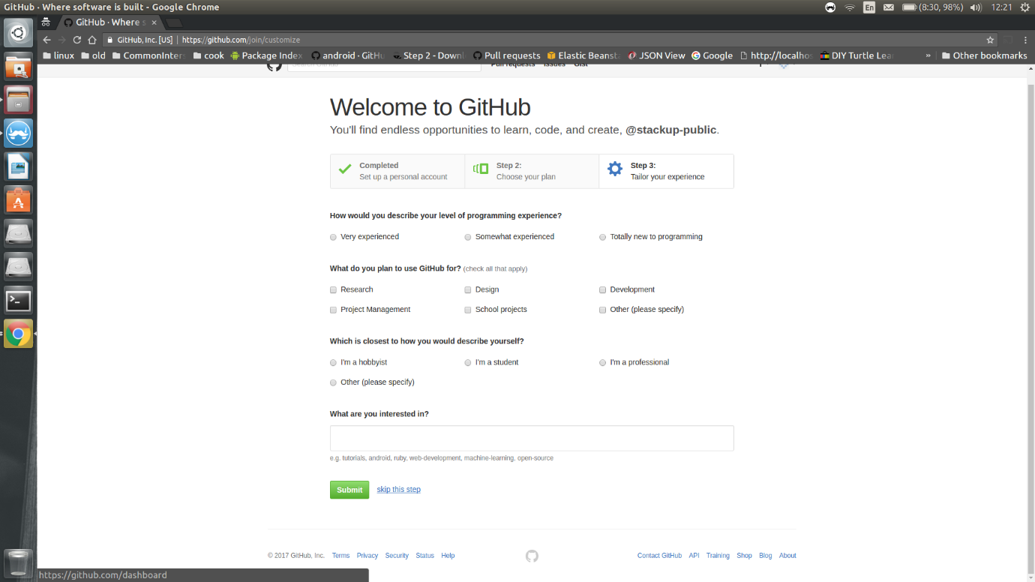

You will be redirected to a page as shown below. Now you need to verify your email-address.

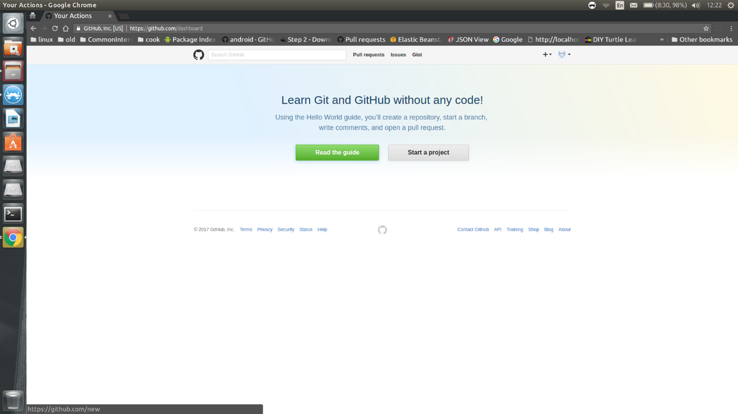

If you try to create any project without verifying your account, it will display something like this. So please verify your email-account.

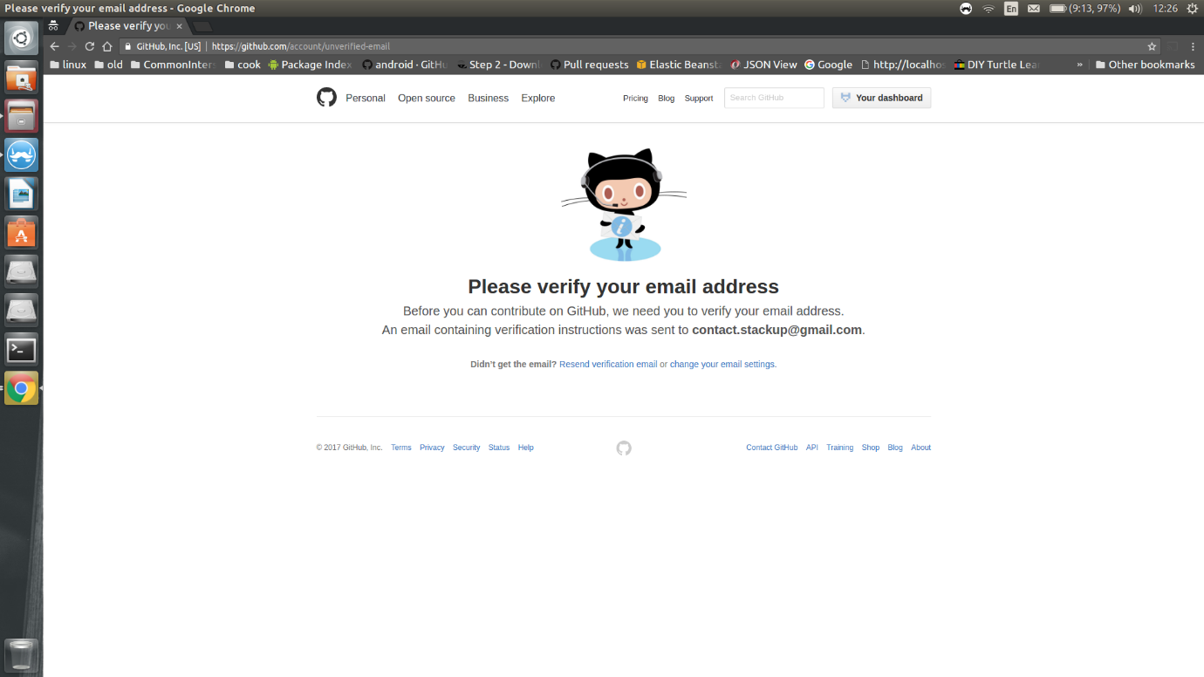

Login to your email account. You should be receiving an email, like this. Please click on "Verify your email address" link below and enter your username and password to verify.

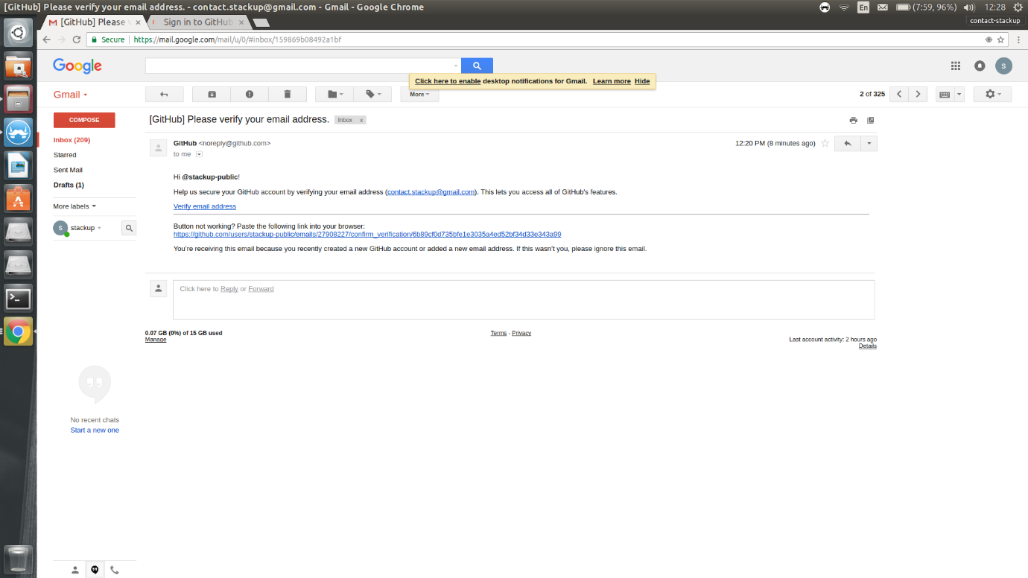

Now you are in github dashboard page

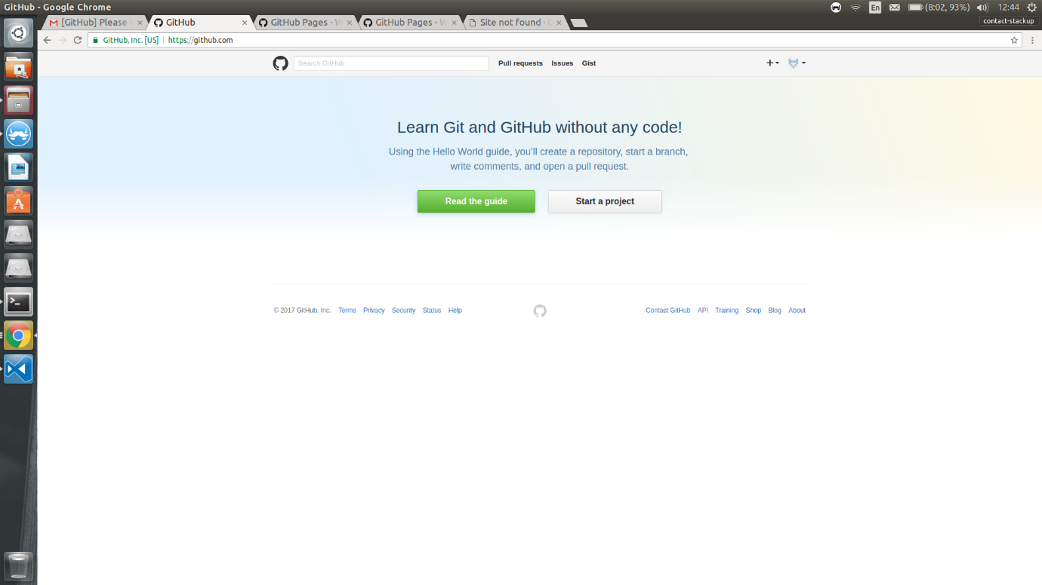

Click on the "+" icon on the top right, and click on "New repository" to create a new repository.

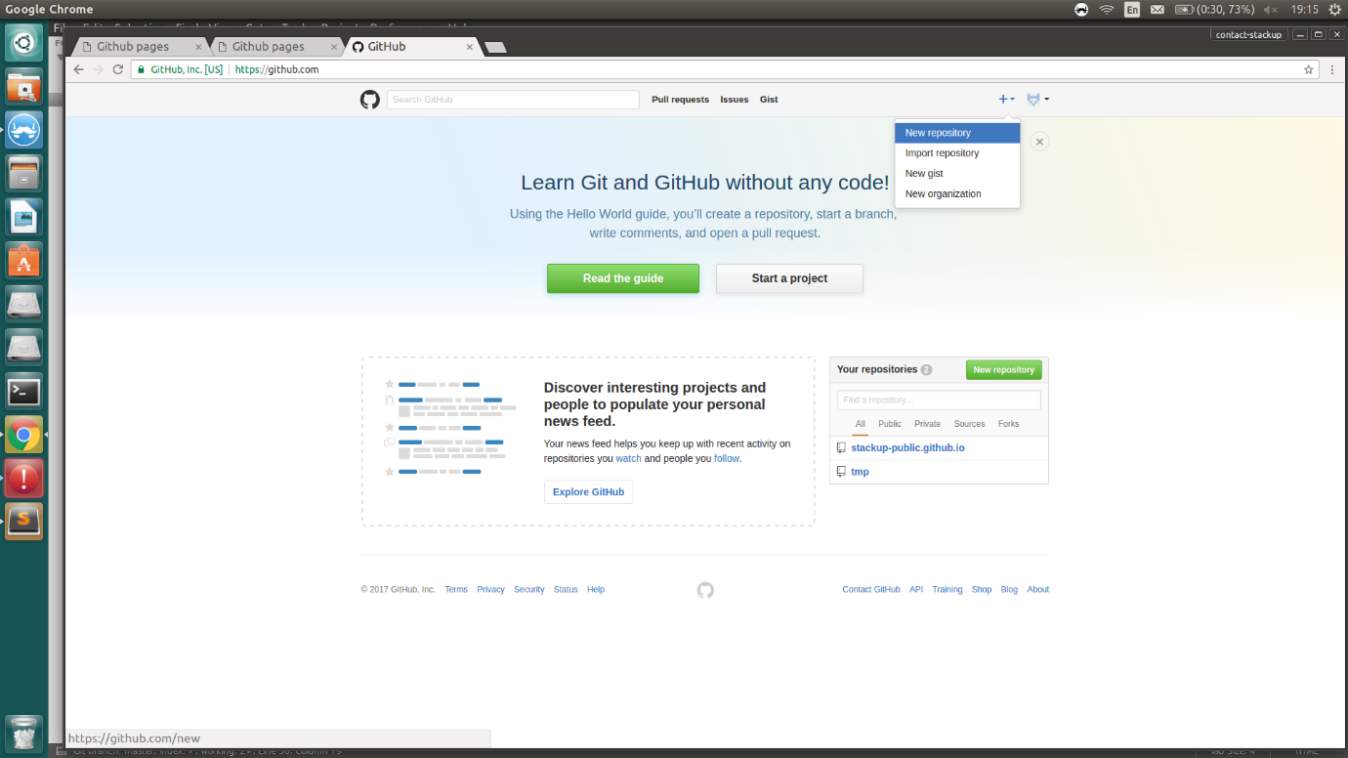

Enter the repository name as "yourusername.github.io".

For eg. if the username is "stackup-public", then repository name should be "stackup-public.github.io"

For eg. if the username is "tom", then repository name should be "tom.github.io"

Syntax: yourusername.github.io

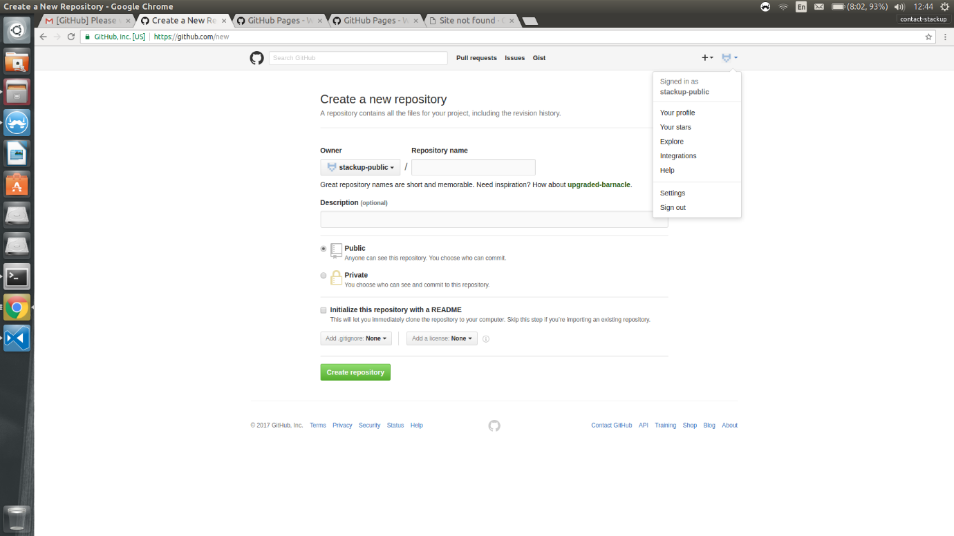

For reference, you can find your username as shown in the image below. Click on the logo at the top right and it will show the username

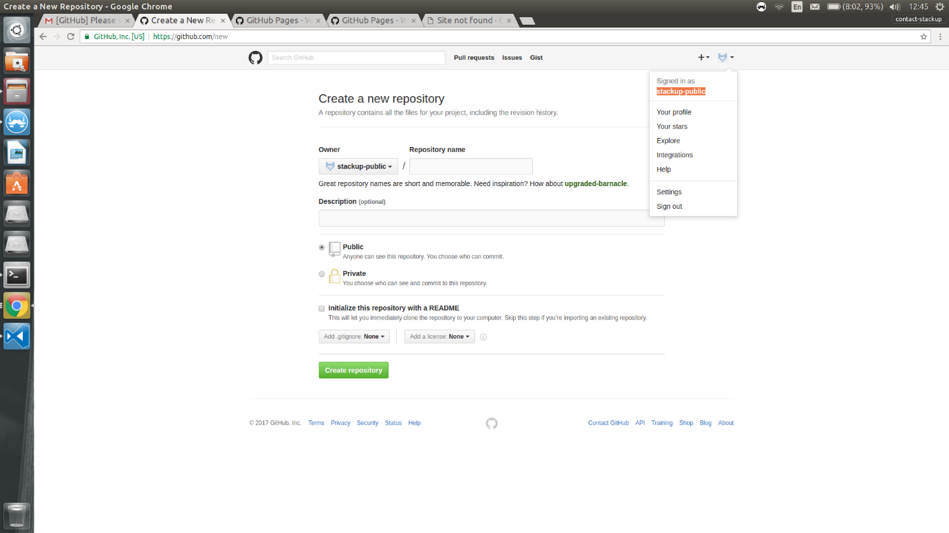

Please fill in your repository name as mentioned above and a description (optional). Let the repository be public. No need to change anything. Click on "Create repository"

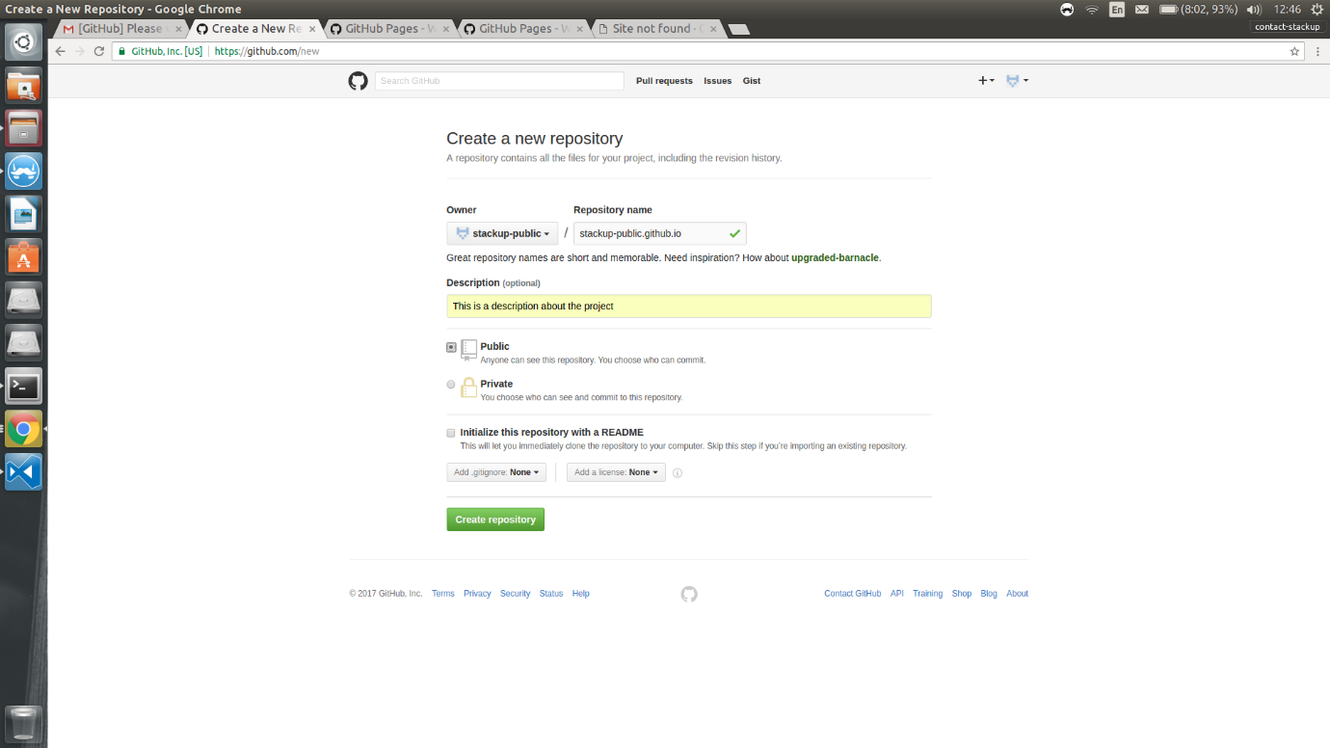

You have successfully created the repository. Please copy the url shown below. We will use it later. Better dont close this browser window, we will come back to it later.

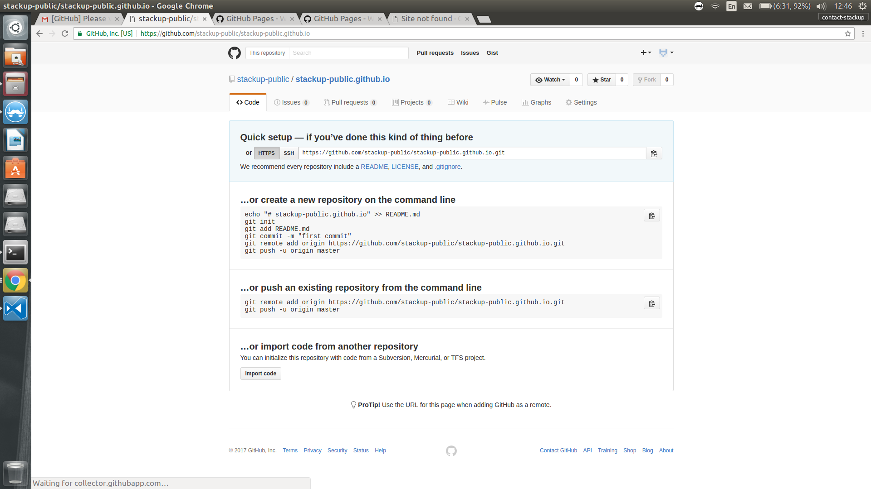

Go to [https://desktop.github.com](https://desktop.github.com/) to download the github client.

We will use this software to push the code, to github repository.

Download and install the software.

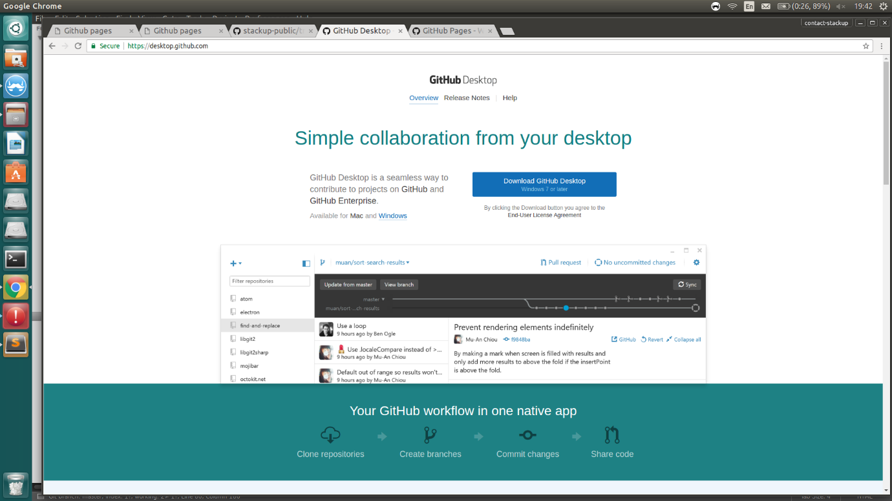

Once installed, it will pop up as like shown below.

Enter your github email-id and password and click "Log in"

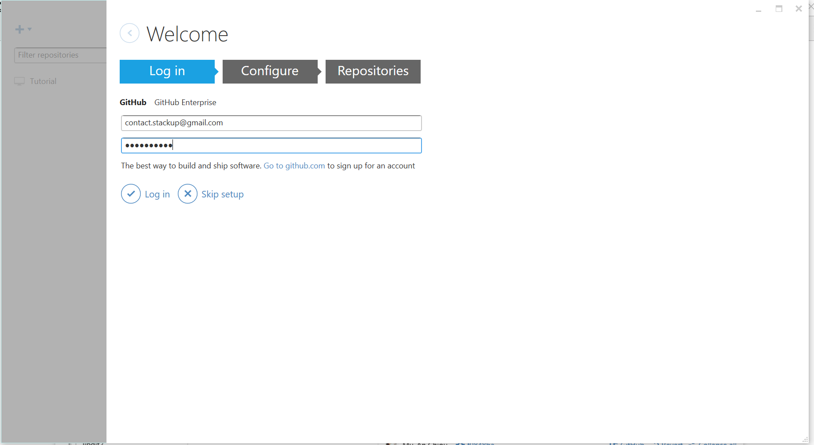

Enter your github username and email id, then click "Continue"

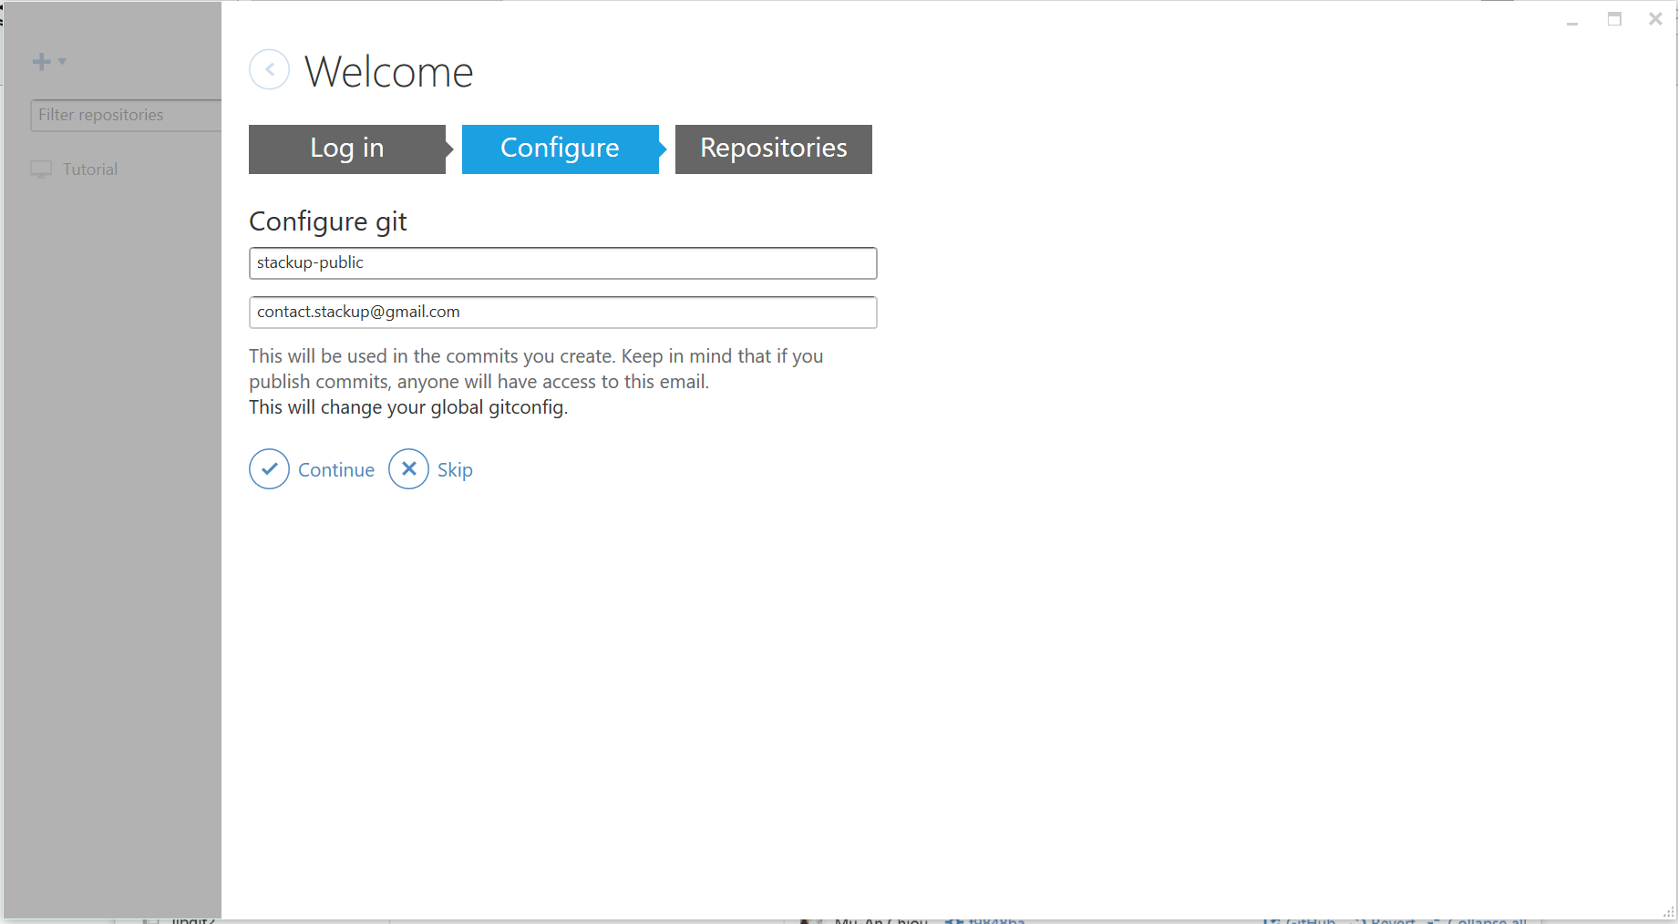

One done, click on the "dashboard" to go the dashboard. The following it the dashboard.

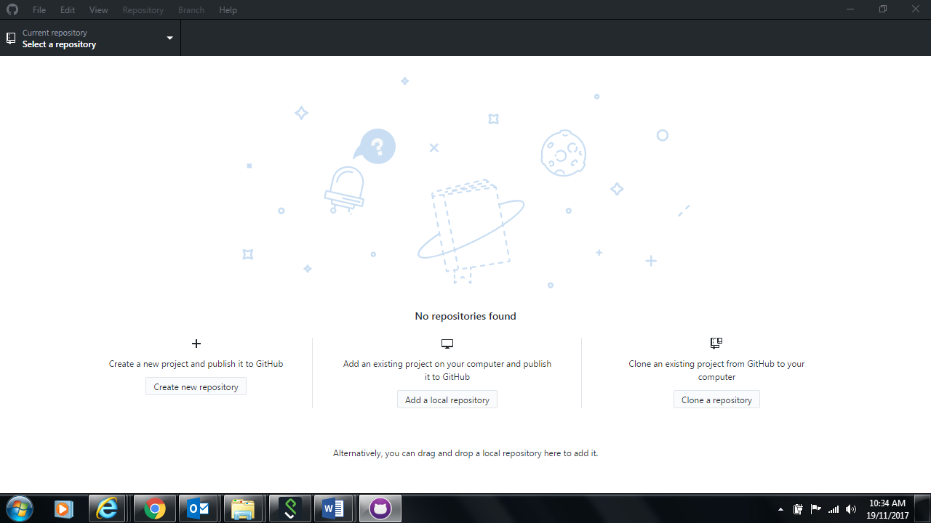

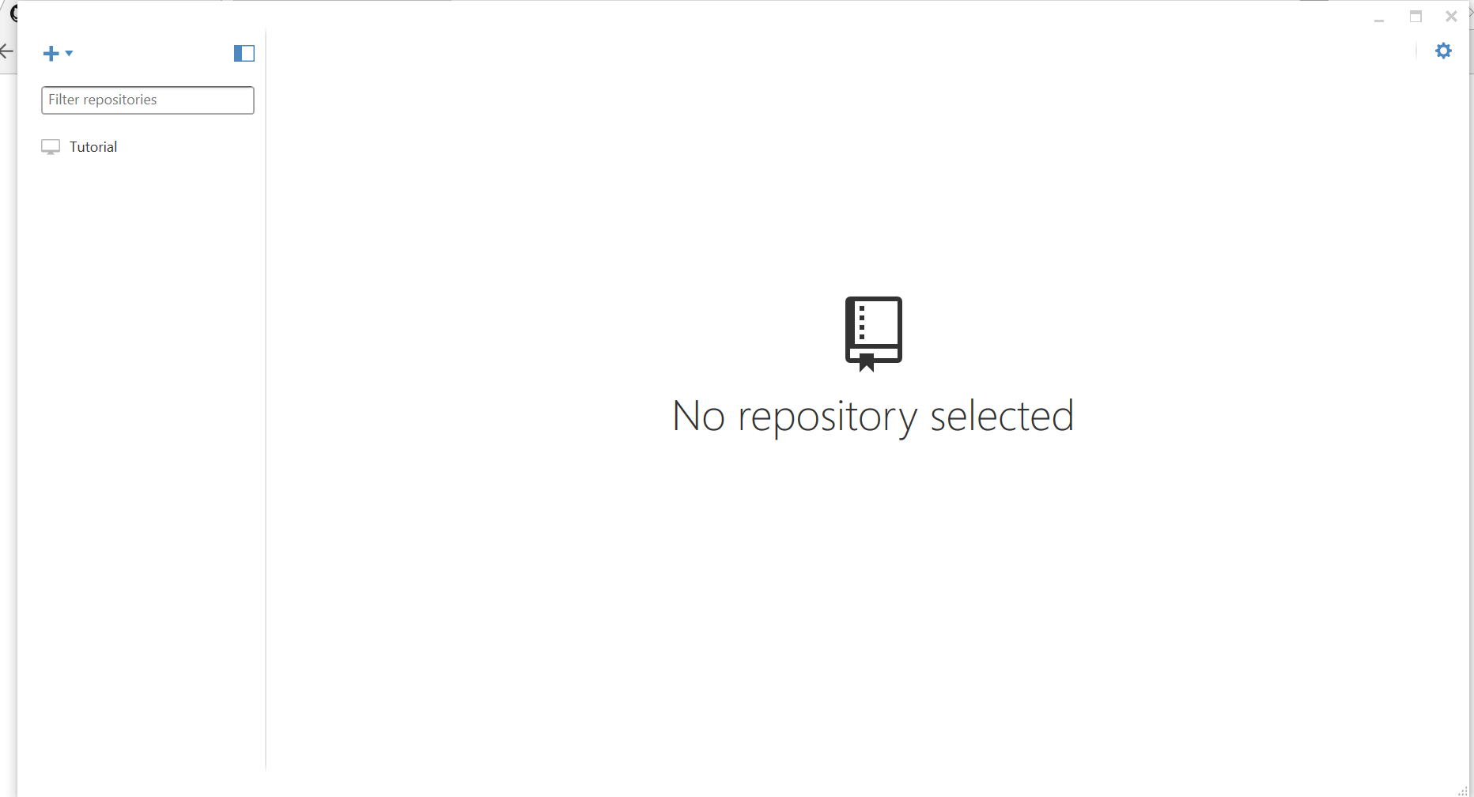

Click on the "+" button on Top left and select "Clone" tab.

Then select the repository that you want to clone. You will be able to see the github repository that you have created earlier.

Select the repository and click "Clone" tick button on the bottom

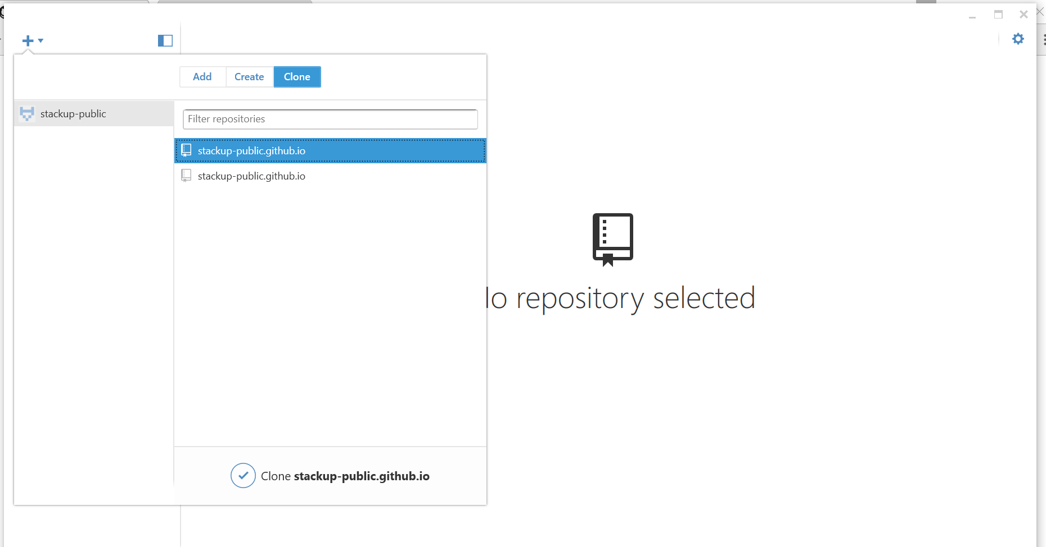

It will prompt you to choose a location/directory to store the files locally.

Select your prefered location/directory and click "Ok".

We will use this location/directory to copy your project file later, to this location.

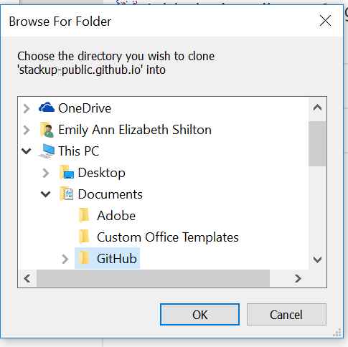

Once done, it should look like this, with no files in it.

Lets go on and copy your project files to this location , in order to push github.

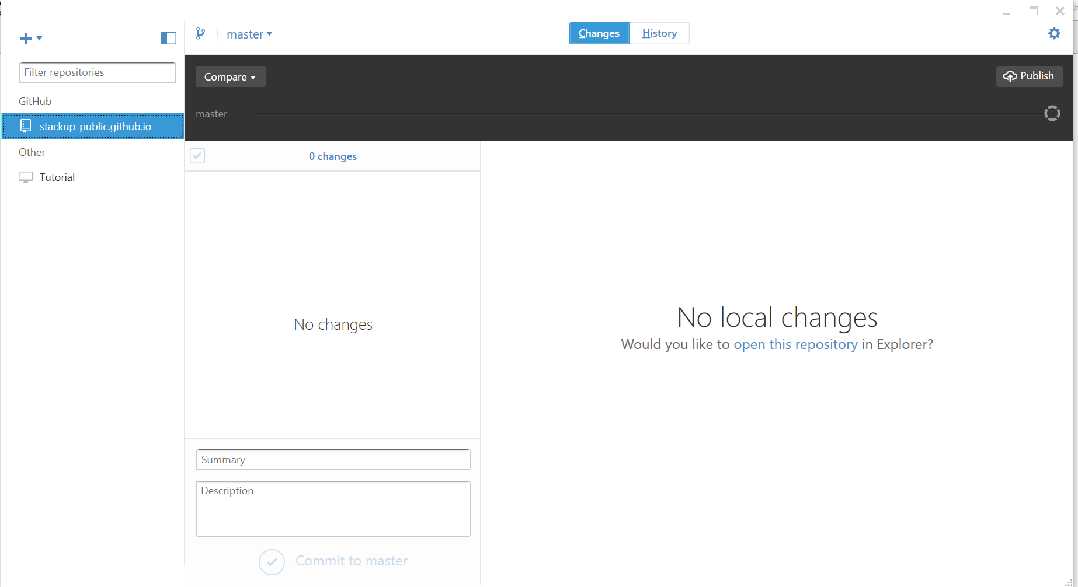

Now copy all your project files, into the location/directory that you have selected in previous steps.

Go to that location/directory and paste your project files.

In this case, i have pasted an index.html, so that you can see those file as shown below.

Depend on your project files, you should be able to see those project files as shown below.

Now enter "summary" and "description", then click on "Commit to master"

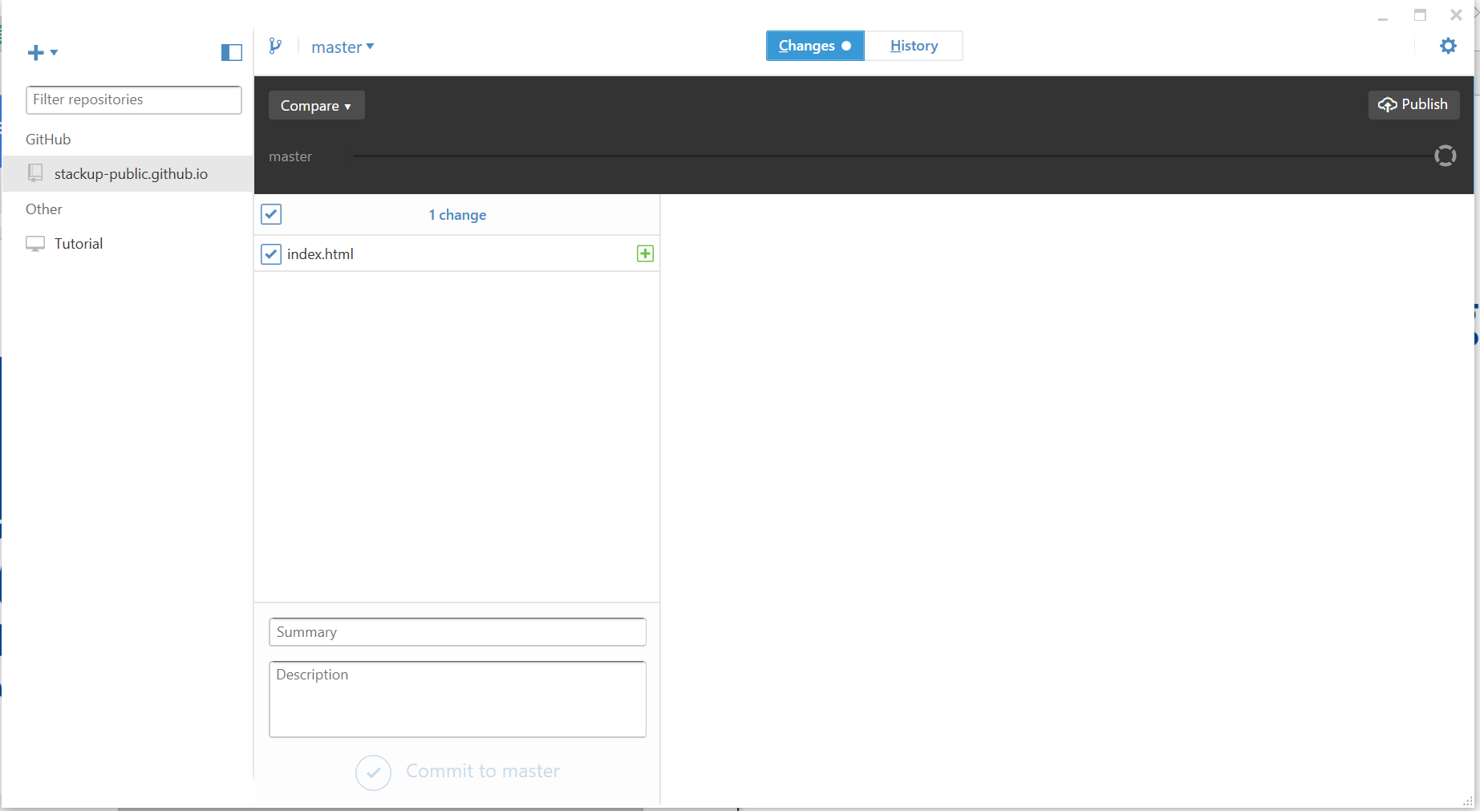

Once committed, it shows "Created commit" with your message at the bottom, as shown below.

On top right there is a "publish" button. Click on it, to push your code/project to github pages.

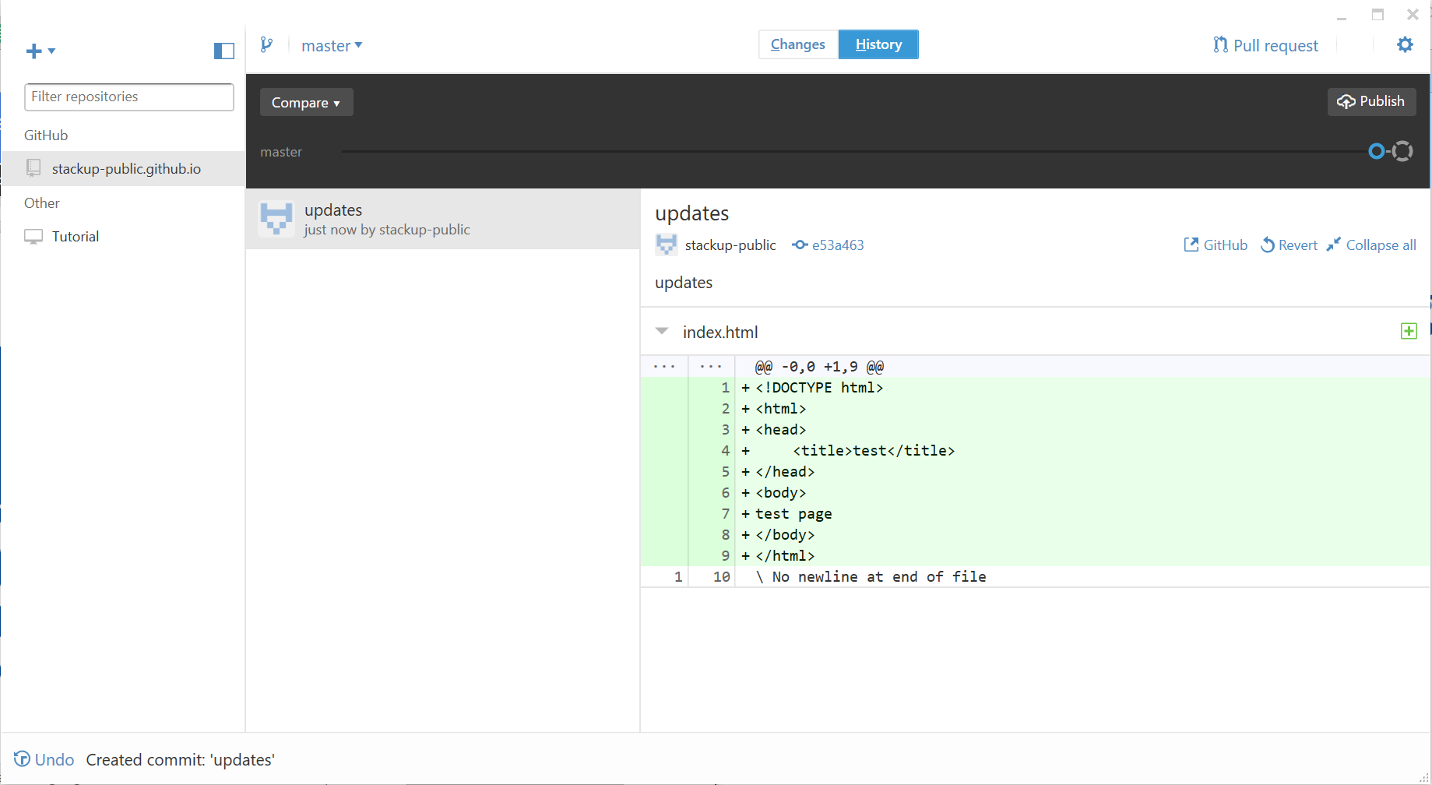

It will take a while to push, meanwhile it show "syncing" on that location as shown below.

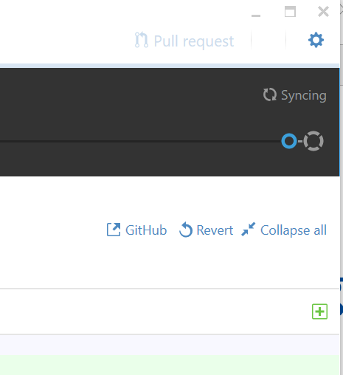

Once done, it show show "sync" option, as show below.

woooo... you have published your website to github.io

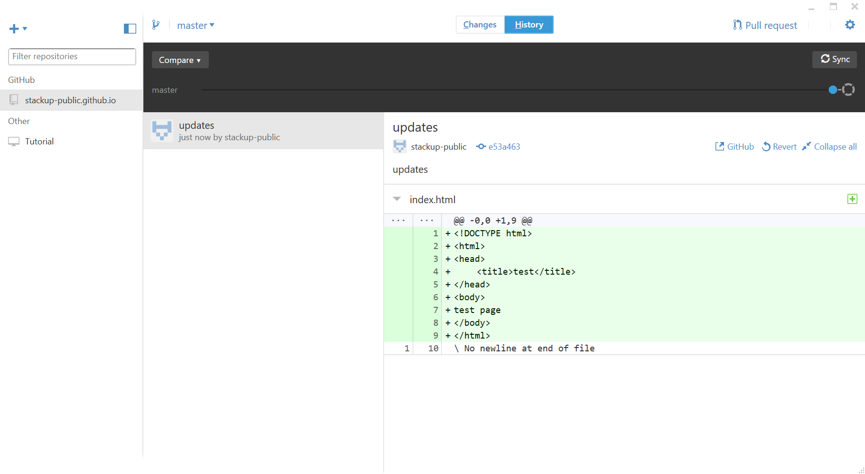

Now go to "username.github.io" to visit your website. [Remember, username should be your github username as you do in the previous steps..]

For eg: In my case, I head over to "stackup-public.github.io"

